Project Design Phase
Problem – Solution Fit
Date | 8 October 2026
Student Name | OviyaShree
Project Name | Metro Ticket Generating System in ServiceNow
Maximum Marks

Problem–Solution Fit
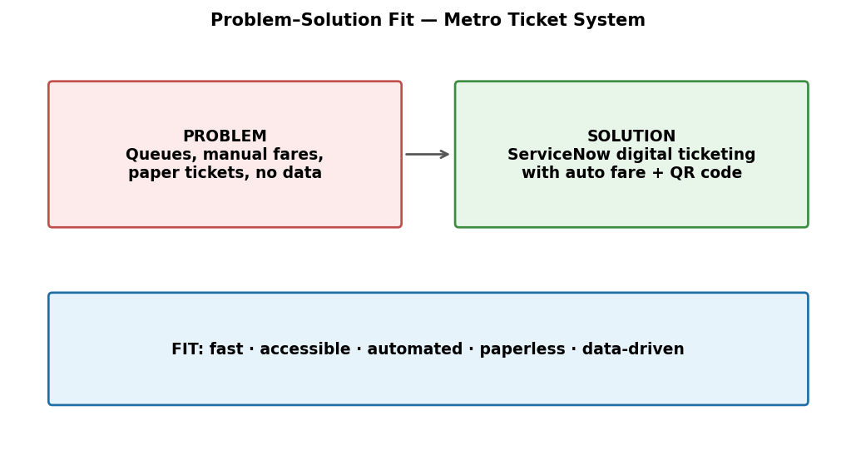
Figure 1: Problem–solution fit canvas adapted to the Metro Ticket project.
Parameter | Project Fit
Problem | Manual metro ticketing causes queues, fare errors and paper waste.
Solution | A ServiceNow Metro Ticket Generating System with automated fare calculation and QR code tickets.
Customer Benefit | Fast, accessible booking and an instant digital ticket.
Operational Benefit | Fewer manual interventions, fewer errors and lower operating cost.
Uniqueness | Combines Service Catalog, Flow Designer, Notifications and QR codes on one platform.
Scalability | Digital payments, WhatsApp booking, analytics and route optimization can be added later.

